To save the build artifacts into amazon s3 we need two things

1. S3 bucket - private
2. AWS user with programmatic access.
3. We need to install a plugin called “Artifact Manager on S3” in jenkins.

**1. How to create a bucket in Amazon S3**

Go to AWS management console and login to the account and open s3 service.

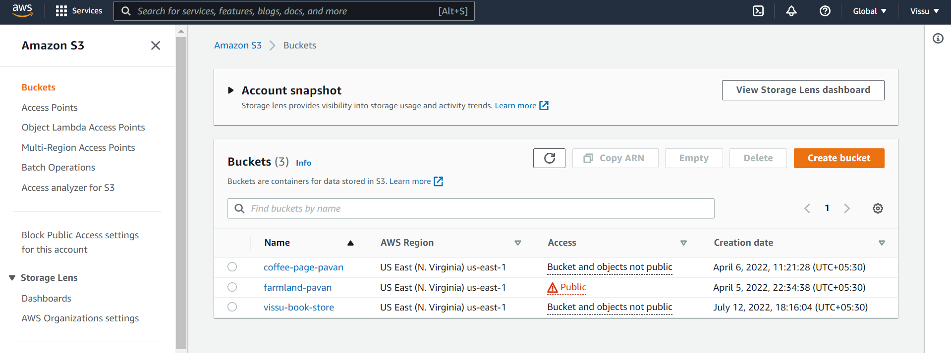

Click on “Create Bucket”

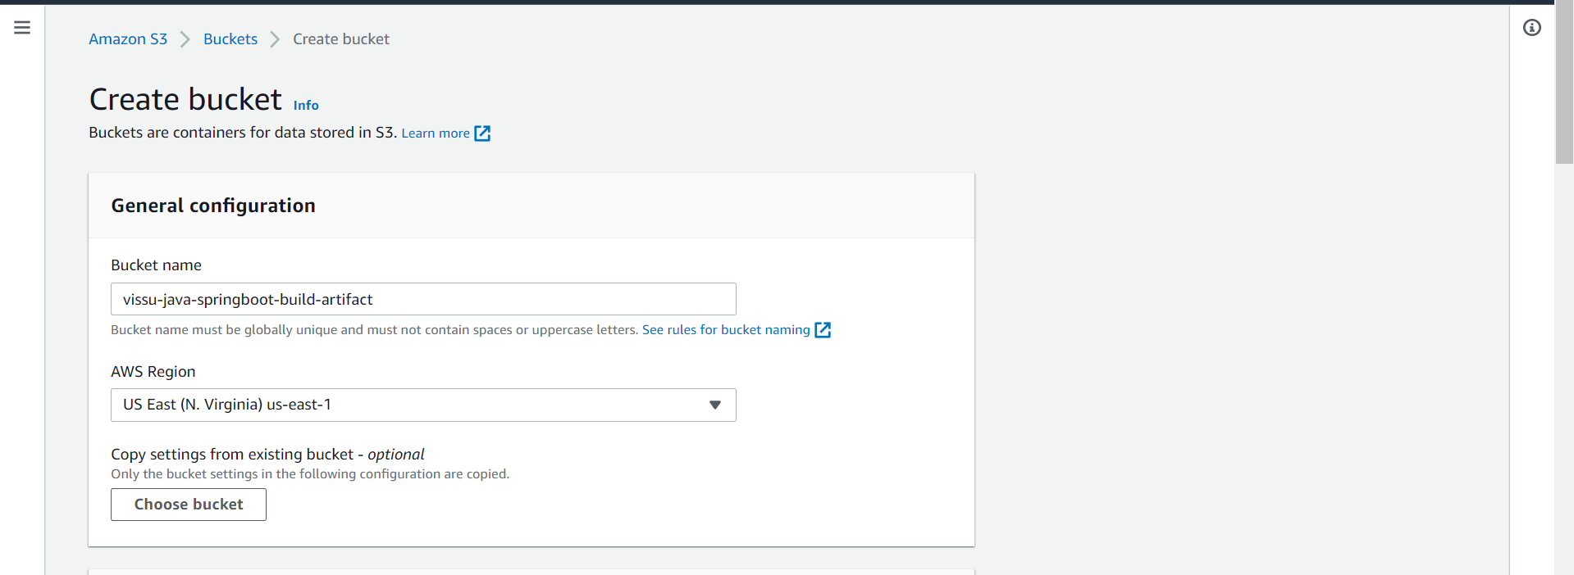

Enter the name for bucket.

Leave all other settings as default.

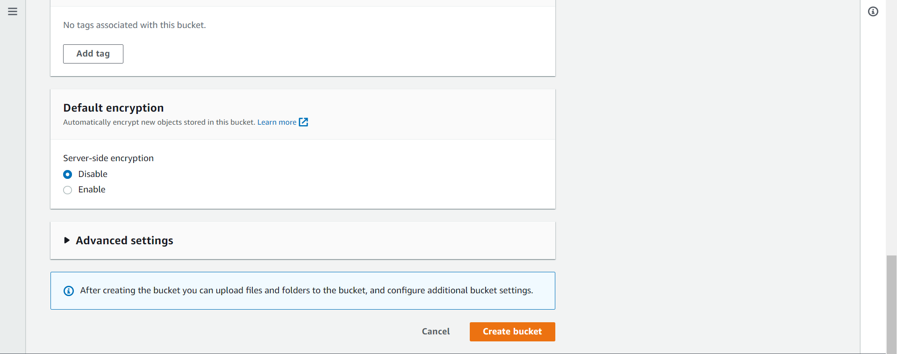

Click on “Create bucket”

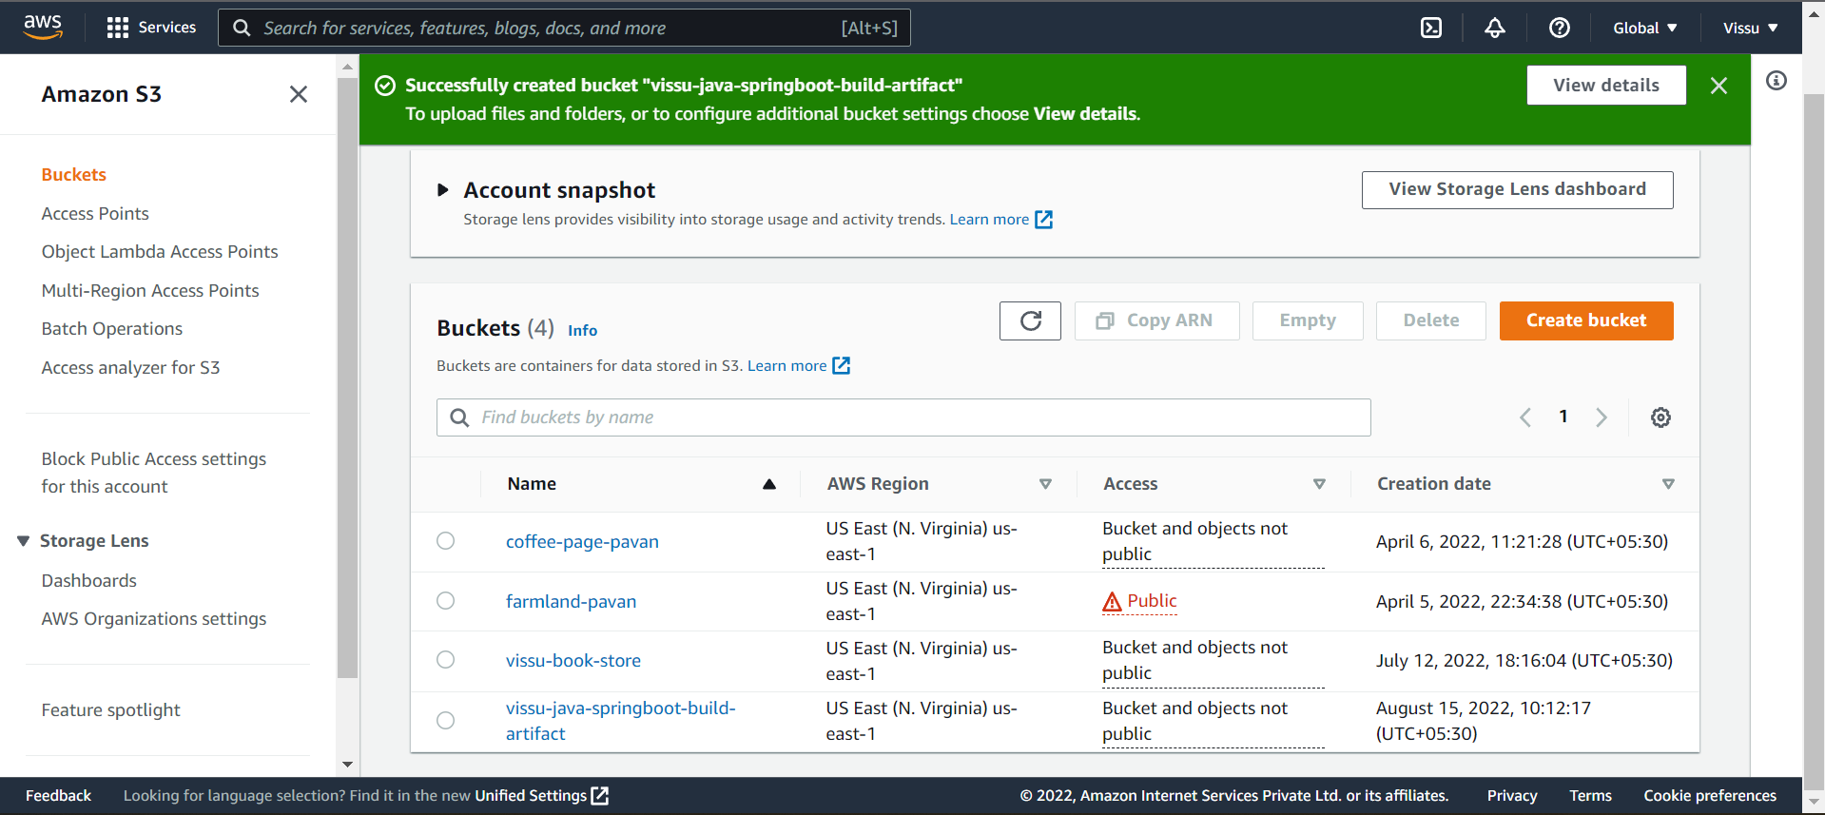

Bucket created successfully.

Creating the policy for the IAM user with programmatic access to grant access to our s3 bucket.

Either we can give s3 full access or can create a new custom policy.

Here I am going for new custom policy.

Click on “Create Policy”

It will open a new tab for the policy creation

Select “JSON” to create the policy

Copy the below policy in the above JSON editor box.

---------------------------------------------------------------------------------------

{

"Version": "2012-10-17",

"Statement": [

{

"Effect": "Allow",

"Action": [

"s3:GetBucketLocation",

"s3:ListAllMyBuckets"

],

"Resource": "arn:aws:s3:::*"

},

{

"Effect": "Allow",

"Action": "s3:ListBucket",

"Resource": "arn:aws:s3:::vissu-java-springboot-build-artifact"

},

{

"Effect": "Allow",

"Action": [

"s3:PutObject",

"s3:GetObject",

"s3:DeleteObject"

],

"Resource": "arn:aws:s3:::vissu-java-springboot-build-artifact/*"

}

]

}

Note:

In the above policy replace the “Resource” value with your bucket ARN.

How to check the bucket ARN?  
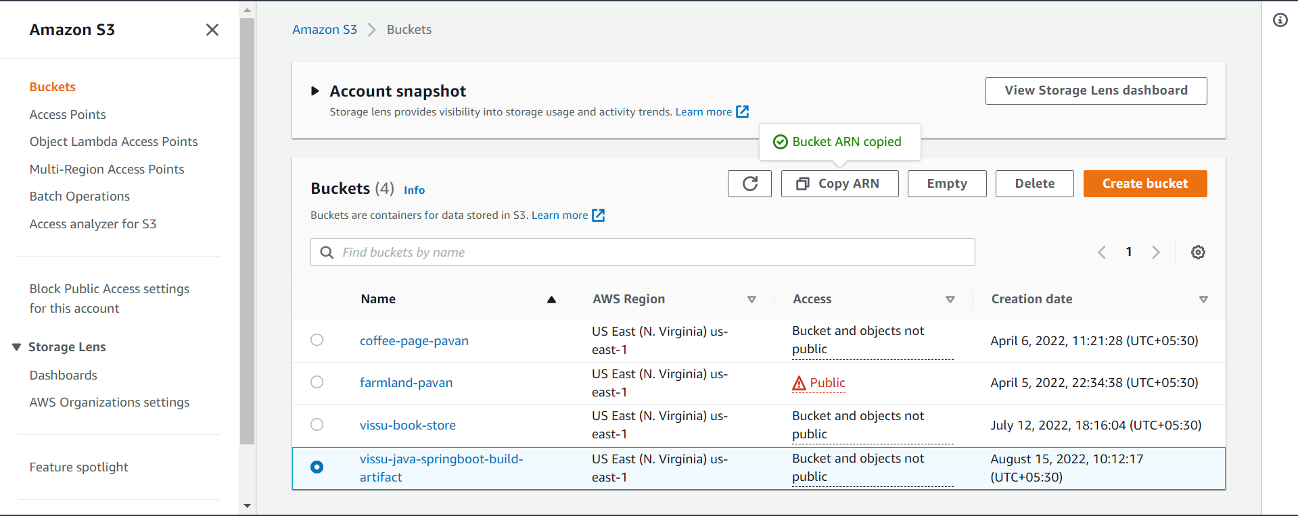

Select your bucket and click on “Copy ARN”.

I just copied and pasted the policy in the JSON editor.

Next click on Tags

Adding tag is optional you can skip it.

Next click on Review.

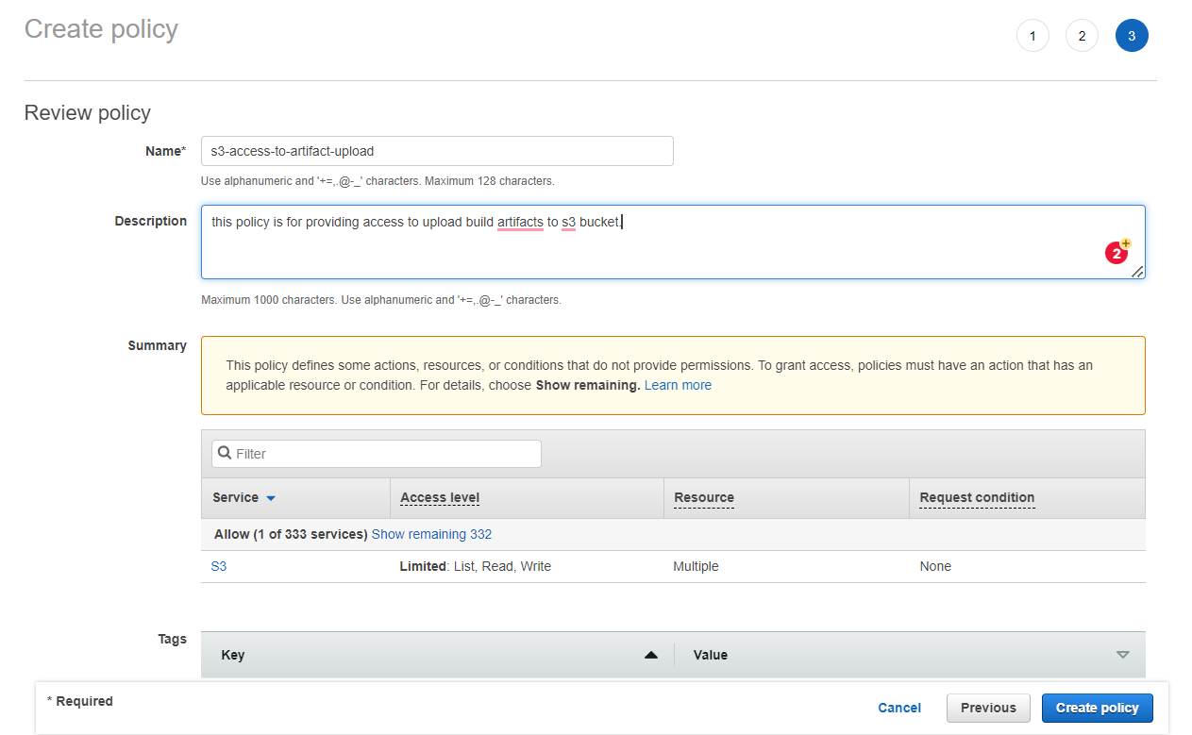

Enter name for the policy

Enter description

Click on “Create policy”

Policy created successfully.

**2. How to create IAM User with programmatic access.**

Go to aws and open IAM Service.

Go to users and click on create user.

Enter name for the user

Select the Access Type = “Programmatic access”.

Click on next permissions

Choose the “Attach existing policies”

Search for our policy we have created above and select it.

Next click on Tags

Tags are optional, we can skip it

Next click on review

Click on create user.

Download the user credentials. We will use these credentials to connect our jenkins server with aws S3.

**3. How to install Artifact Manager on S3 plugin on jenkins?**

Open jenkins server

Go to Manage Jenkins 🡺 Manage plugins

Search for the plugin in available plugins, select it and click on “Install without restart”.

Installation started.

Installation completed.

Restart the Jenkins once.

Jenkins is restarting.

Jenkins restarted, login to the jenkins.

Now, configure the aws credentials in jenkins

**How to configure AWS in S3?**

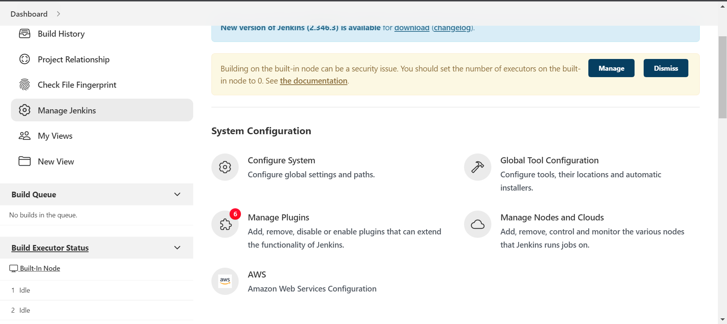

Go to manage jenkins 🡺 AWS

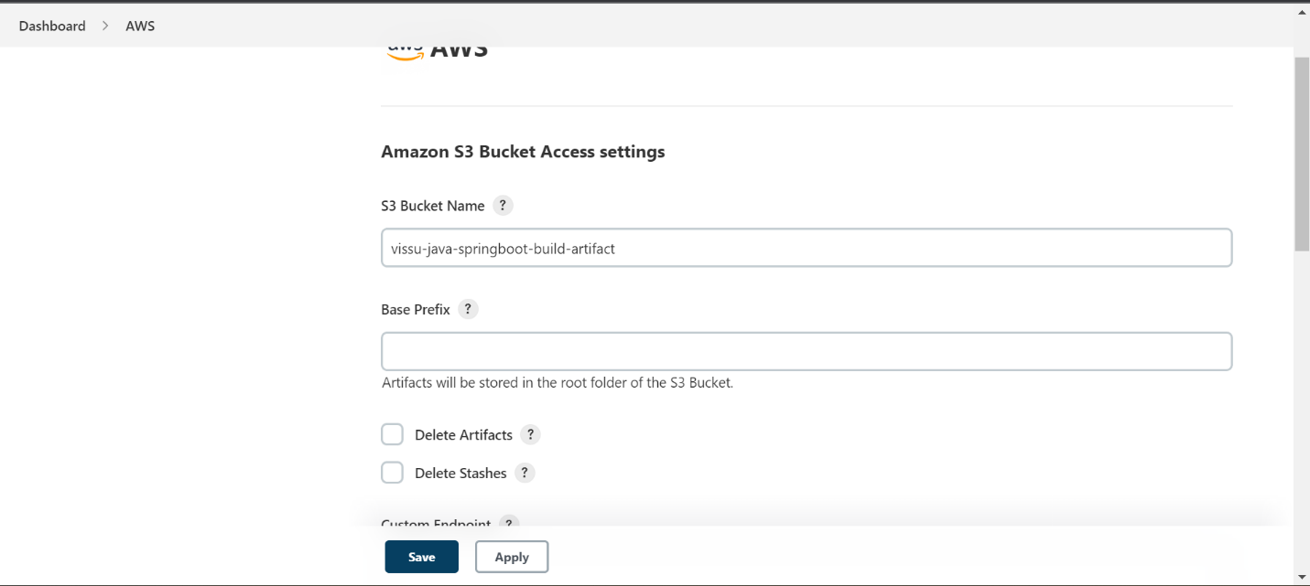

Enter your S3 bucket name.

Select the “region” in which your bucket is created. Or you can leave it to auto.

Click on “Add” to add the credentials.

This will open a pop-up window.

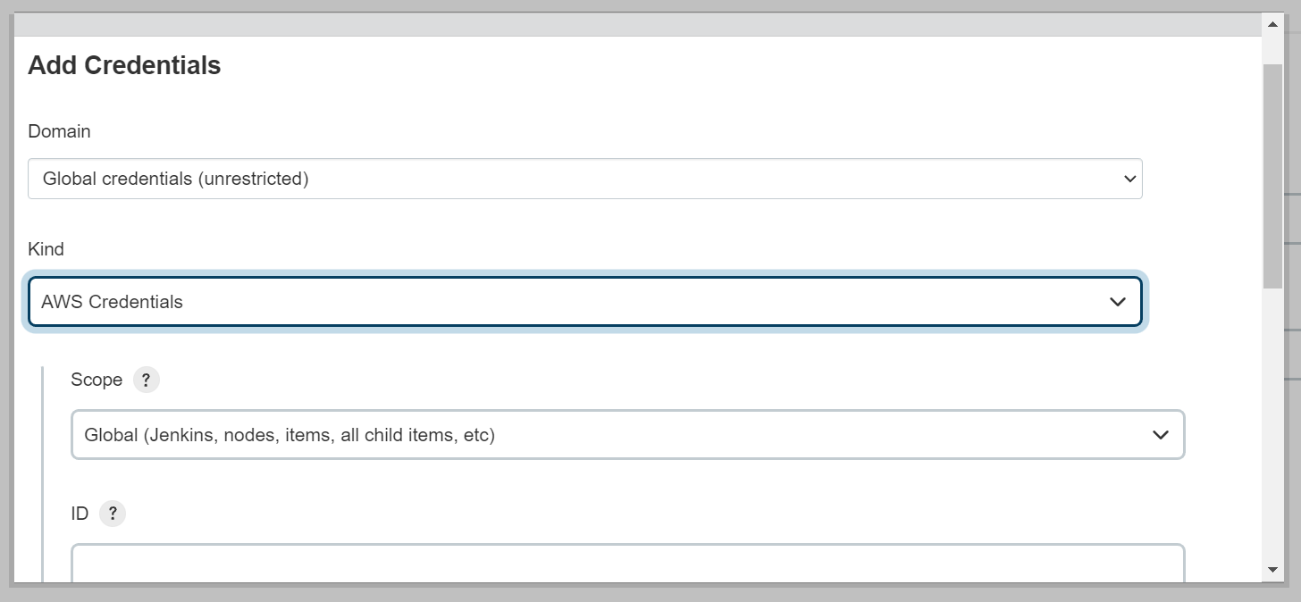

Select the kind as “AWS Credentials”.

Select the scope

Give an ID for the credentials

Enter the description

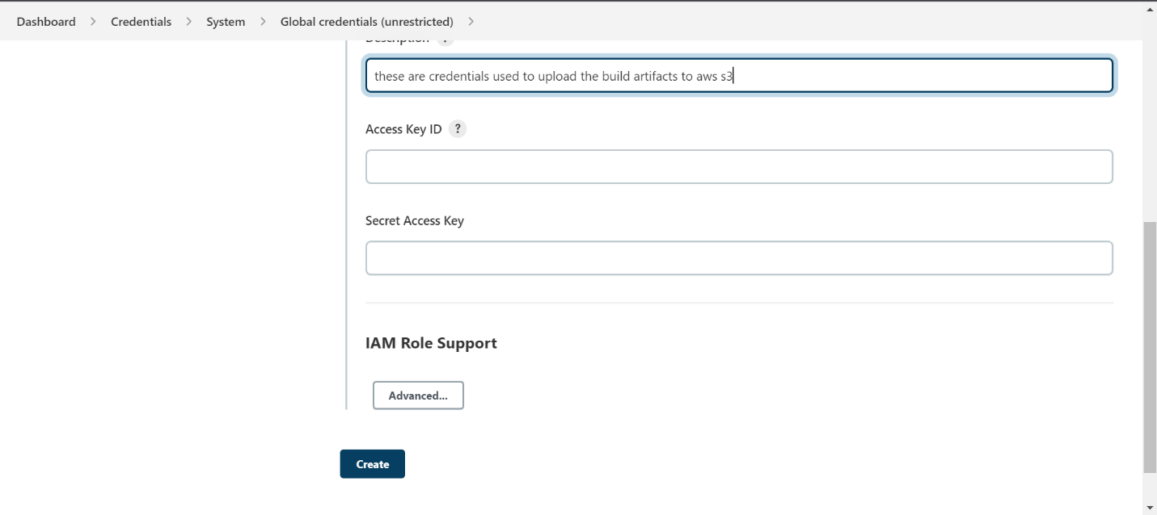

Enter the “Access key ID” and “Secret Access Key” for the IAM User we created above.

Copy this access key id and access key and paste in the above fields.

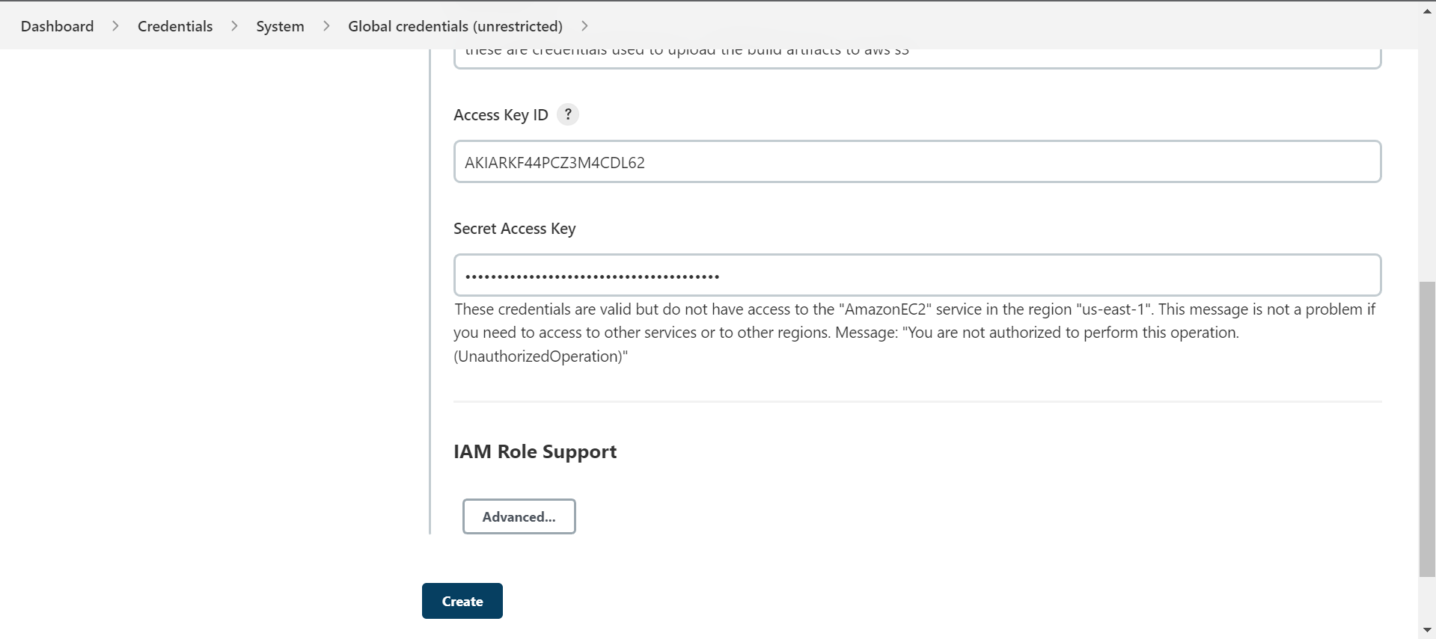

Click on create.

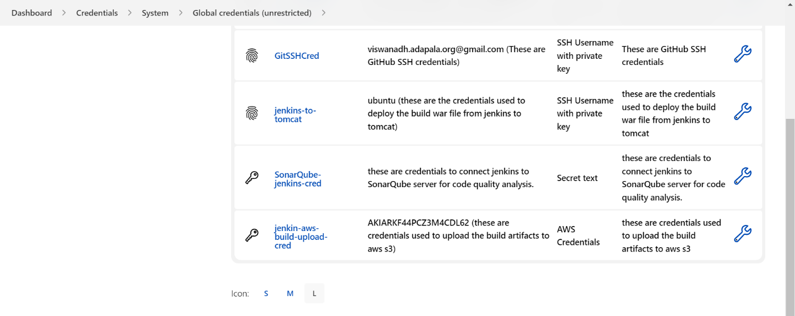

Credentials are added successfully.

Now, enable to store the build artifacts into S3 in jenkins.

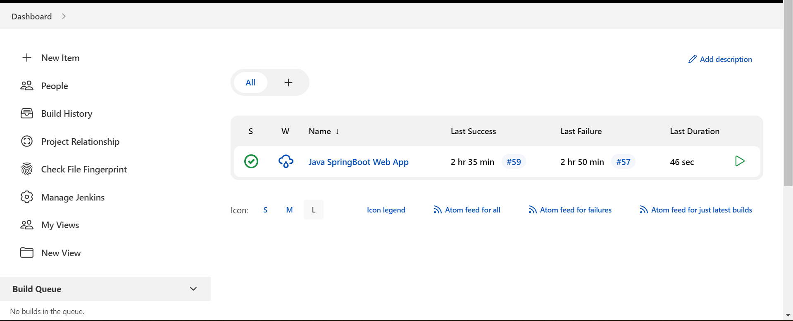

Go to manage jenkins

Go to “configure system”

Go to “Artifactory Management for Builds”

Click on “Add”

Select “Cloud Artifact Storage”

Select the cloud provider as “Amazon S3”

Click on apply and save.

Now, add the build archive stage in our pipeline job.

How, to add build archive stage in jenkins pipeline job

Write the build archive code inside the steps.

Code: archiveArtifacts artifacts: '**/*.war', followSymlinks: false

Write this code inside steps.

Click on Apply and Save.

Now, let’s build the pipeline again.

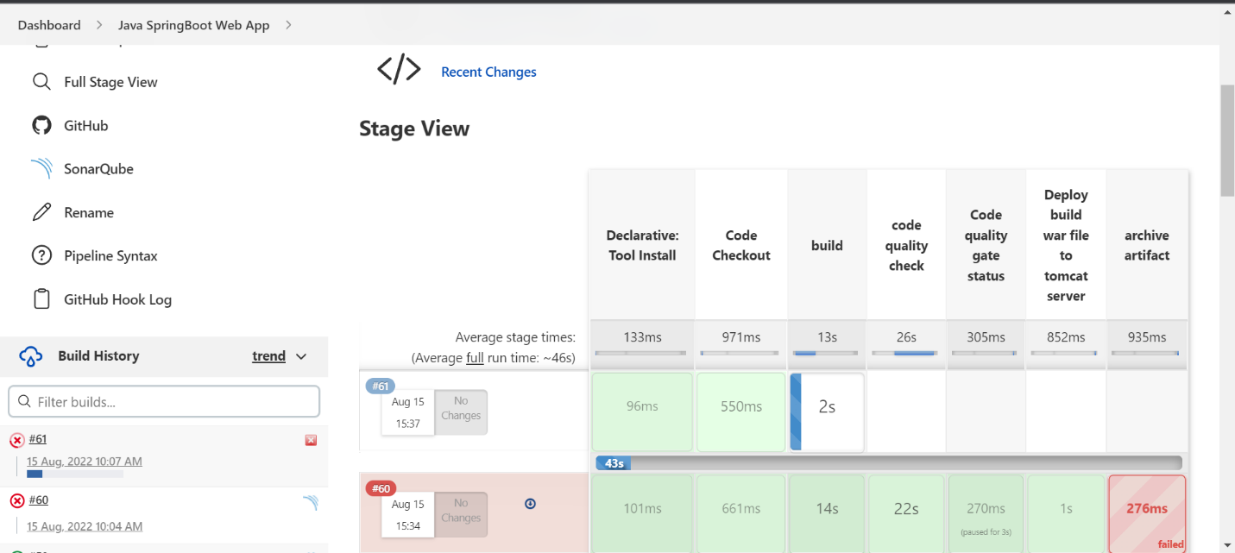

Our new build 61 was started.

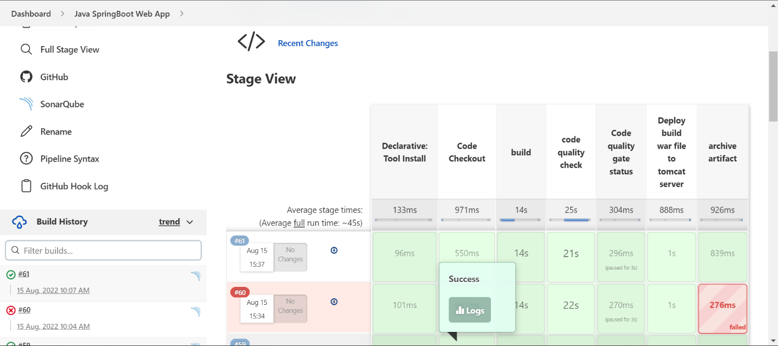

New build got success.

Let’s check the archive logs

Artifacts are uploaded to aws s3 successfully.

Let’s verify.

Go to aws s3 bucket and refresh it once.

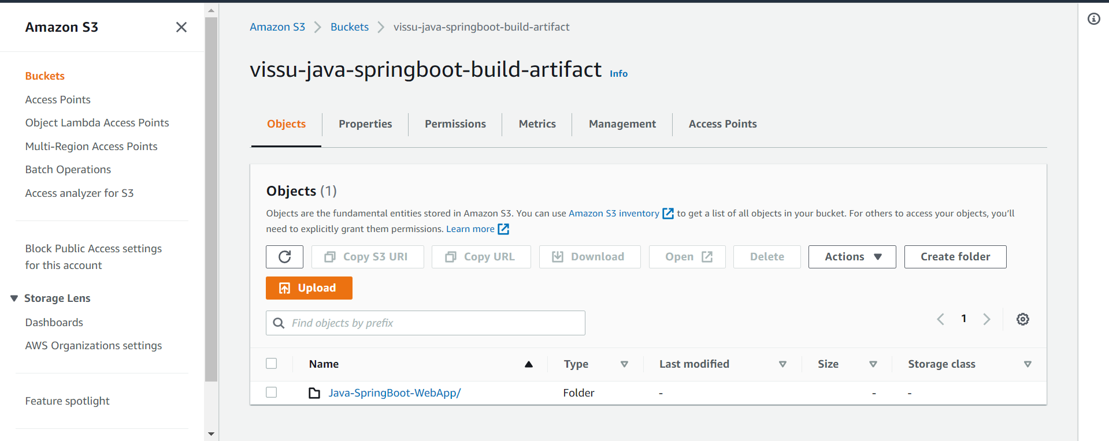

A new folder is created with our project GitHub repo name.

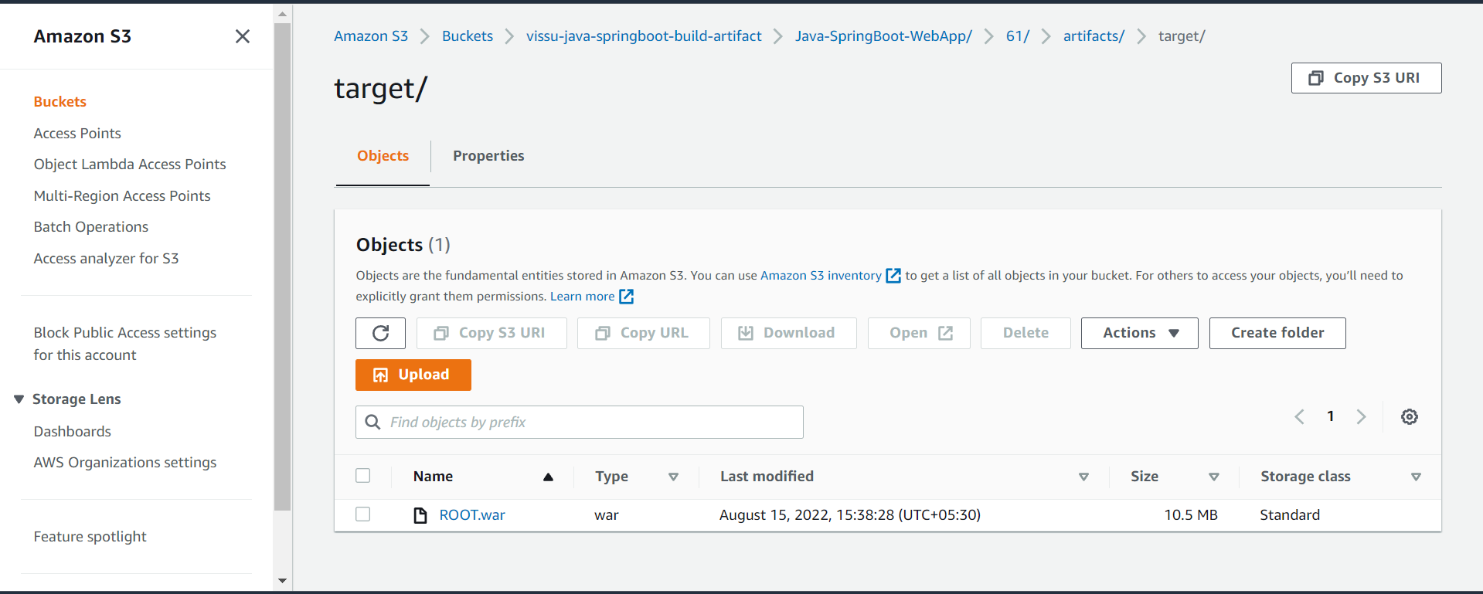

Our build artifact file “ROOT.war” file is created under build id 61 🡺 artifacts 🡺 target.